**Meta Description:** The Shiba Inu price’s falling wedge pattern sparks price predictions, while FloppyPepe (FPPE) is poised for potential explosive growth.

**Keywords:**

Shiba Inu Price

Shiba Inu

FloppyPepe

FPPE

# **Shiba Inu Price Prediction: Falling Wedge Pattern Continues, FloppyPepe (FPPE) Positioned For Explosive Growth**

Experts have noticed the formation of a falling wedge pattern on the Shiba Inu price chart. This historic signal for a potential breakout has created market uncertainty as some traders anticipate a bullish reversal. Amid the volatile movements of the Shiba Inu price, a new opportunity is gaining traction among investors. [FloppyPepe (FPPE)](https://floppypepe.io/), an AI-powered meme coin, has emerged as a high-growth contender poised for explosive gains. With excellent AI-driven features, passive income rewards, and a rapidly selling presale, FloppyPepe (FPPE) is capturing the attention of those seeking the next big crypto success story.

## **FloppyPepe (FPPE): The AI Meme Coin Redefining Utility And Long-Term Value**

While other meme tokens depend on media hype and market speculation to reclaim their past highs, [FloppyPepe (FPPE)](https://floppypepe.io/), an AI meme coin steals the show with better inherent value. The AI-powered token began its journey with a rapid private round that recorded over $900,000 in a day. Since integrating AI technology, passive income rewards, and a deflationary burn mechanism into a formidable network, institutional experts are bullish on FloppyPepe (FPPE).



FloppyPepe (FPPE) has set the standard with its outstanding features. Its **Meme-o-Matic AI agent** is now available on the community’s Telegram platform. This technology helps traders create and earn from digital content. Crypto beginners can also use the **AI video agent** to learn about market trends and price fluctuations. These features and more incoming ones show that this AI meme token will become a real utility in the coming days.

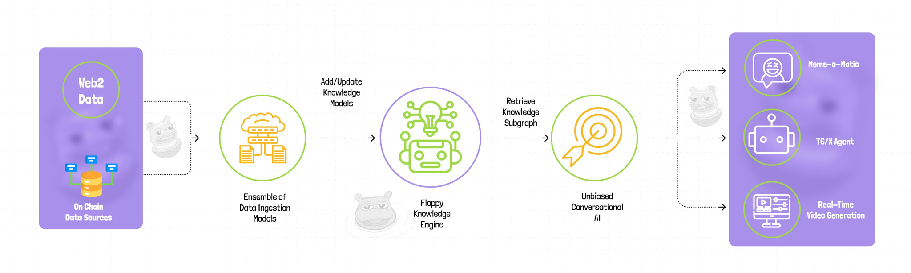

Beyond its sophisticated technology, FloppyPepe (FPPE) encourages short-term investors with menial gains and long-term holders with value appreciation. Its **deflationary burn mechanism** regulates token supply and improves scarcity for consistent price growth. It has a passive income structure for token holders to earn 3% from every transaction. Unlike other speculative meme coins, FloppyPepe (FPPE) has inherent financial incentives for all kinds of investors.

The network underwent a [smart audit contract](https://app.solidproof.io/projects/floppypepe) by SolidProof to safeguard all investments on the platform. FloppyPepe (FPPE) also allocates a fraction of its revenue to **wildlife conservation**. This social responsibility towards global preservation resonates with industry experts who love to invest in real-world assets. 

FloppyPepe (FPPE) provides a good entry point with its affordable **$0.0000002** price. Early investors are the biggest beneficiaries of this success story. With more investors moving to AI cryptocurrencies because of their real value, FloppyPepe (FPPE) has emerged as the leading contender. NASS crypto has backed this AI meme coin to grow exponentially and reward early adopters with mouthwatering gains.

## **Shiba Inu Price Prediction: Hope Wanes As Falling Wedge Pattern Lingers**

## Analysts have identified a notable [falling wedge pattern](https://x.com/javontm1/status/1890887452161716589?s=46) on the Shiba Inu price chart. However, they added that the token seems to have broken out and could be ready for an incredible run. While these analysts expect the Shiba Inu price to push to a new all-time high, they urge investors to look elsewhere as the surge grows bleak. The AI buzz for the crypto world is [expanding](https://x.com/jasoncryptoftw/status/1894553176327573689?s=46) as investors seek early access to utility-driven crypto growth. However, industry experts have backed FloppyPepe (FPPE) over other established memecoins while they await a potential breakout from the Shiba Inu price.

## **FloppyPepe (FPPE) Presale: Early Access To Utility-Driven Crypto Growth**

While the Shiba Inu price’s falling wedge pattern hints at a potential breakout, traders are uncertain about its next move. Unlike Shiba Inu’s (SHIB) holders, savvy investors search for projects with real utility and long-term growth potential. [FloppyPepe (FPPE)](https://floppypepe.io/), an incredible AI meme coin, has shown how it is beyond media hype.

With its rapidly selling presale and analyst-backed growth projections, FloppyPepe (FPPE) is proving to be more than another meme coin. With the market sentiment shifting toward utility-driven assets, FloppyPepe (FPPE) has become a strong contender for explosive growth in 2025 and beyond. Early adopters will be the biggest rewarders in the new wave.

**Join the FloppyPepe (FPPE) presale and community:   
Website:** [**https://floppypepe.io/**](https://floppypepe.io/) **Whitepaper:** [**https://floppypepe.gitbook.io/floppypepe.io**](https://floppypepe.gitbook.io/floppypepe.io) **Telegram:** [**https://t.me/floppypepeofficial**](https://t.me/floppypepeofficial) **X (Twitter):** [**https://x.com/floppypepe**](https://x.com/floppypepe)

